E-commerce Site

By

Rajan lahoti

(Software Engineer, Espire Infolabs, 2021)

Approved By:

**Table of Contents**

Abstract 4

1. Introduction 5

1.1 Goal 5

1.2 Need of the application 5

1.3 Existing system 6

1.4 Proposed system 6

1.4.1 Factors influencing consumer to shop online 6

1.5 Scope 7

1.5.1 Hardware Interfaces 7

1.5.2 Software Interfaces 8

2. Review of literature 8

3. System Requirement Analysis 9

3.1 Information Gathering 9

3.2 System Feasibility 9

3.2.1 Economic Feasibility 9

3.2.2 Technical Feasibility 9

3.3 Use Case Diagram 10

3.4 Class Diagram 11

3.5 Object Diagram 12

3.6 Sequence Diagram 13

3.7 Package Diagram 13

3.8 Deployment Diagram 14

4. Analysis of consumer behaviour online 14

5. Results, Data analysis and Discussions 15

Demography Factor: 16

5.1 Analysis and Interpretation 16

Behavioural factors: 19

Analysis and Interpretation: 19

Mode of awareness about Flipkart.com 20

6. Testing and implementation 21

7. Recommendations: 27

7. Conclusion 28

7.1 Limitations 29

7.2 Future Scope 29

8. References 29

# Abstract

Electronic Commerce is process of doing business through computer networks. A person sitting on his chair in front of a computer can access all the facilities of the Internet to buy or sell the products. Unlike traditional commerce that is carried out physically with effort of a person to go & get products, ecommerce has made it easier for human to reduce physical work and to save time. Security is the challenge facing e-commerce today & there is still a lot of advancement made in the field of security. The main advantage of e-commerce over traditional commerce is the user can browse online shops, compare prices and order merchandise sitting at home on their PC.

The main objective of the E-commerce Portal is to manage the details of Products, Customer, Shipping, Payment, and Category. It manages all the information about Products, Sales, Category, and Products. The project is totally built at administrative end and thus only the administrator is guaranteed the access. The purpose of the project is to build an application program to reduce the manual work for managing the Products, Customer, Sales, and Shipping. It tracks all the details about the Shipping, Payment, and Category.

# Introduction

1. **E-COMMERCE**

Although the terms e-commerce and e-business are often used interchangeably, there are differences. E-commerce is the buying and selling of goods and services on the Internet or other computer network. Any brick and mortar store can become an e-commerce business by adding a virtual storefront with an online catalogue. In most cases, e-business refers exclusively to Internet businesses, but it may also refer to any business that uses Internet technology to improve productivity and profitability.

1. **E-BUSINESS**

Business transactions that involve the exchange of money are covered by the term e-commerce. E-business includes all aspects of running a business that sells goods and services, including marketing, earning and retaining customers, procurement, developing business partners and customer education. In order to be successful, e-commerce and e-businesses must have quality storefronts that are simple to navigate and peruse, with accurate and thorough catalogue information. E-business became an extension of e-commerce to encompass all aspects of businesses that function online. E-business involves e-commerce, but e-

Commerce does not cover all aspects of e-business.

1. **BUSINESS MODELS** E-Commerce or Electronics Commerce business models can generally be categorized in the following categories:-

* Business - to - Business (B2B)
* Business - to - Consumer (B2C)
* Consumer - to - Consumer (C2C)
* Consumer - to - Business (C2B)
* Business - to - Government (B2G)
* Government - to - Business (G2B)
* Government - to - Citizen (G2C)

Flip kart houses everything you can possibly imagine, from trending electronics like laptops, tablets, smartphones, and mobile accessories to in-vogue fashion staples like shoes, clothing and lifestyle accessories; from modern furniture like sofa sets, dining tables, and wardrobes to appliances that make your life easy like washing machines, TVs, ACs, mixer grinder juicers and other time-saving appliances.

**NEED OF THE STUDY (E-COMMERCE)**

**1.     Exploitation of New Business**

Broadly speaking, electronic commerce emphasizes the generation and exploitation of new .business opportunities and to use popular phrases: “generate business value” or “do more with less”.

**2.     Enabling the Customers**

Electronic Commerce is enabling the customer to have an increasing say in what products are made, how products are made and how services are delivered (movement from a slow order fulfillment process with little understanding of what is taking place inside the firm, to a faster and rt1ore open process with customers having greater control.

**3.     Improvement of Business Transaction**

Electronic Commerce endeavors to improve the execution of business transaction over various networks.

**4.     Effective Performance**

It leads to more effective performance i.e. better quality, greater customer satisfaction and better corporate decision making.

**5.     Greater Economic Efficiency**

We may achieve greater economic efficiency (lower cost) and more rapid exchange (high speed, accelerated, or real-time interaction) with the help of electronic commerce.

**6.     Execution of Information**

It enables the execution of information-laden transactions between two or more parties using inter connected networks. These networks can be a combination of ‘plain old telephone system’ (POTS), Cable TV, leased lines and wireless. Information based transactions are creating new ways of doing business and even new types of business.

**7.     Incorporating Transaction**

Electronic Commerce also inco11'orates transaction management, which organizes, routes, processes and tracks transactions. It also includes consumers making electronic payments and funds transfers.

**8.     Increasing of Revenue**

Firm use technology to either lower operating costs or increase revenue. Electronic Commerce has the Potential to increase revenue by creating new markets for old products, creating new information-based products, and establishing new service delivery channels to better serve and interact with customers. The transaction management aspect of electronic commerce can also enable firms to reduce operating costs by enabling better coordination in the sales, production and distribution processes and to consolidate operations arid reduce overhead.

**9.     Reduction of Friction**

Electronic Commerce research and its associated implementations is to reduce the “friction” in on line transactions frictions is often described in economics as transaction cost. It can arise from inefficient market structures and inefficient combinations of the technological activities required to make a transaction. Ultimately, the reduction of friction in online commerce will enable smoother transaction between buyers, intermediaries and sellers.

**10.   Facilitating of Network Form**

Electronic Commerce is also impacting business .to business interactions. It facilitates the network form of organization where small flexible firms rely on other partner, companies for component supplies and product distribution to meet changing customer demand more effectively. Hence, an end to end relationship management solution is a desirable goal that is needed to manage the chain of networks linking customers, workers, suppliers, distributors and even competitors. The management of "online transactions" in the supply chain assumes a central roll.

**11.   Facilitating for Organizational Model**

It is facilitating an organizational model that is fundamentally different from the past. It is a control organization to the information based organization. The emerging forms of techno-organizational structure involve changes in managerial responsibilities, communication and information flows and work group structures.

## 1.1 Goal

The main goal of e-commerce websites development is to sell products to users. The most successful websites are carefully optimized to achieve a high percentage of purchases. To achieve success e-commerce websites need to integrate all of the latest online closing & upsell techniques available which have been proven to increase the chances that a visitor will purchase.

There are many important elements that go into building a successful e-commerce website such as removing friction during the purchasing process, making the checkout smooth and easy, making the website fast and attractive, up selling users on related products, incentivizing buyers, reducing cart abandonment, nurturing past buyers to buy again, remarketing to past visitors who haven’t yet purchased, using the proper payment options, having a mobile ready design and many more things which are needed to develop and e-commerce website.

## 1.2 Need of the application

With the help of ecommerce web design you get an opportunity to have your products and services available to customers 24 hours. It gives a good exposure to your business and help you to reach out to potential customers. Since most of the people prefer to shop online due to paucity of time, you can easily make more revenue. With the help of an e-commerce website people can select and buy desired products anytime. They can pay easily through credit cards or other payment options available in website.

When it comes to buying gifts for your family and friends, an ecommerce shopping cart is what people prefer these days. Almost everything is available over internet. You just need to visit the website, select a product, and add it in your shopping cart and pay. The gift will be delivered to the mentioned destination on time. Is not that simple and hassle free?

Another feature of an e-commerce website is that you can save an item in your 'wish list' and buy it later.

## 1.3 Existing system

This existing system of buying goods has several disadvantages. It requires lots of time to travel to the particular shop to buy the goods. It is having lots of manual work. Since everyone is leading busy life now a days, time means a lot to everyone. Also there are expenses for travelling from house to shop. It is less user-friendly. In current system user must go to shop and order products. It is difficult to identify the required product. More over the shop from where we would like to buy something may not be open 24*7*365. Hence we have to adjust our time with the shopkeeper’s time or vendor’s time. In current e commerce system user have to go shop to view the description of the product. It is unable to generate different kinds of report.

## 1.4 Proposed system

The proposed system helps in building a website to buy, sell products or goods online using internet connection. Unlike traditional commerce that is carried out physically with effort of a person to go and get products, e- Commerce has made it easier for human to reduce physical work and to save time. The basic concept of the application is to allow the customer to shop virtually using the Internet and allow customers to buy the items and articles of their desire from the store. E-commerce is fast gaining ground as an accepted and used business paradigm.

### 1.4.1 Factors influencing consumer to shop online

Though there are several factors that influence consumers to shop online, but there are mainly four factors which influence consumer to shop online after reading literature in the field on consumer attitudes towards online shopping and these factors are discussed below in brief.

#### 1.4.1.1 Convenience

Convenience factor refers that it is easy to browse or search the information through online is easier than the traditional retail shopping. Through online, consumers can easily search product catalogue but if the consumer look generally for the same product or item in a traditional store manually it is difficult to visit physically and time consuming also. Convenience has always been a prime factor for consumers to shop online.

#### 1.4.1.2 Time saving

Time savings is one of most influencing factors of online shopping. Browse or search an online catalogue can save time and patience. People can save time and can reduce effort by shopping online. One possible explanation that online shopping saves time during the purchasing of goods and it can eliminate the traveling time required to go to the traditional store. On the other side, some respondent think that it is also time taken for delivery of goods or services over online shopping.

#### 1.4.1.3 Website design/features

Website design and online shopping activity is one of the vital influencing factors of online shopping. Website design features can be considered as a motivational factor that can create positive or negative feelings with a website. If website is designed with quality features it can guide the customers for successful transactions and attract the customers to revisit the website again.

#### 1.4.1.4 Security

Security is another dominant factor which affects consumers to shop online. However many internet users avoid online shopping because of credit card fraud, privacy factors, non-delivery risk, post purchase service and so on. But transaction security on the online shopping has received attention. Safe and secured transaction of money and credit card information increases trust and decreases transaction risk.

## 1.5 Scope

Online shopping is rising day by day in India. Because India is the country where computer users are increasing day by day so as the online shopping trends are also increasing. This project covers the online selling of cosmetics, fashion accessories, watches etc. The project shows the product category and then product details. From the product details, the product can be added to cart and can be bought.1.5 Platform Specifications – Deployment

### 1.5.1 Hardware Interfaces

Since the application must run over the internet, all the hardware shall require to connect internet will be hardware interface for the system. As for e.g. Modem, WAN – LAN, Ethernet Cross-Cable.

### 1.5.2 Software Interfaces

1. The flipkart e-store system shall communicate with the Configurator to identify all the available components to configure the product.

2. The flipkart e-store shall communicate with the content manager to get the product specifications, offerings and promotions.

3. The flipkart e-store system shall communicate with bill Pay system to identify available payment methods, validate the payments and process payment.

4. The flipkart e-store system shall communicate to credit management system for handling financing options.

5. The flipkart e-store system shall communicate with CRM system to provide support.

6. The flipkart e-store system shall communicate with Sales system for order management.

7. The flipkart e-store system shall communicate with shipping system for tracking orders and updating of shipping methods.

8. The flipkart e-store system shall communicate with external Tax system to calculate tax.

9. The flipkart e-store system shall communicate with export regulation system to validate export regulations.

10. The system shall be VeriSign like software which shall allow the users to complete secured transaction. This usually shall be the third party software system which is widely used for internet transaction.

# 2. Review of literature

Several researchers have carried out studies in their effort to examine consumer’s online buying behaviour. For example, Bellman et al (1999) investigated various predictors for whether an individual will purchase online. These authors concluded that demographic variables, such as income, education and age, have a modest impact on the decision of whether to buy online, whereas the most important determinant of online shopping was previous behaviour, such as earlier online purchases. This is consistent with Forrester Research which proved that demographic factors do not have such a high influence on technology as the consumers attitudes do (Modahl, 2000). Steinfield and Whitten (1999) suggested that the combination of the Internet, plus physical presence, provides more opportunities to capture business than the online-only presence, because they can provide better pre-purchase and post-sales services to lower consumer transaction cost and build trust in online stores.

# 3. System Requirement Analysis

## 3.1 Information Gathering

Users who know about the product should be able to find the product easily with the click of a button. Such users can search for the product by using the product name as the search term. Users who have to figure out the product that would satisfy their needs could use a search term to find a list of products and then should be able to filter the results based on various parameters like product type, manufacturer, price range, platform supported etc.

The users should be able to view the complete specification of the product and various images at different Zoom levels. The user should be able to read the customer reviews for the product and the ratings provided. They should be able to write their own reviews. They should be able to print out the specifications for a product or email the product page to a friend’s etc.

To increase the ease of use the user should be able to add a product to the shopping cart by dragging a product and dropping it in the shopping cart. A user should able to edit the contents of a shopping cart. They should be able to update the quantities of the products added to the cart and remove the products from the cart. The user should be able to remove the product from the shopping cart by dragging the product and dropping it outside the cart. The application can be made interactive by pop up messages when a product has been dropped in to the shopping cart or out of the shopping cart.

## 3.2 System Feasibility

The system feasibility can be divided into the following sections:

3.2.1 Economic Feasibility

The project is economically feasible as the only cost involved is having a computer with the minimum requirements mentioned earlier. For the users to access the application, the only cost involved will be in getting access to the Internet.

3.2.2 Technical Feasibility

To deploy the application, the only technical aspects needed are mentioned below:

Operating Environment Window 10

Platform Amazon Web Service

## 3.3 Use Case Diagram

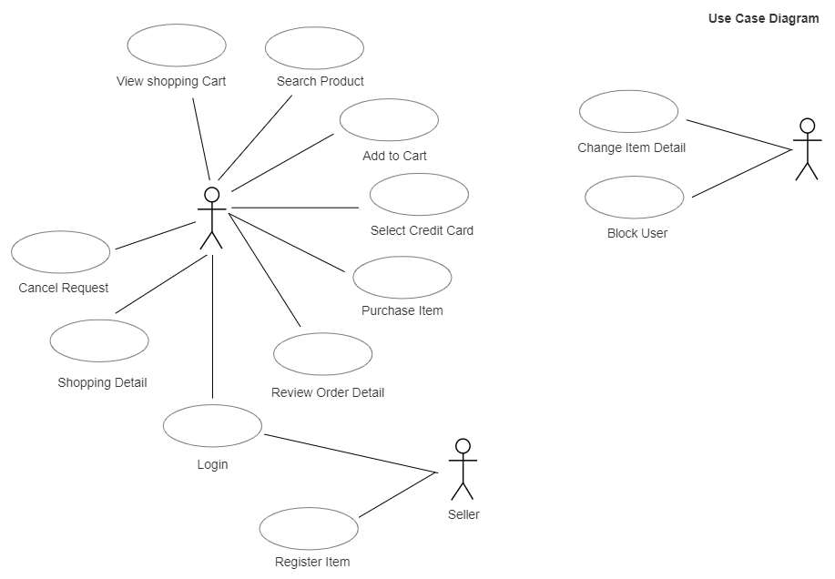

## 3.4 Class Diagram

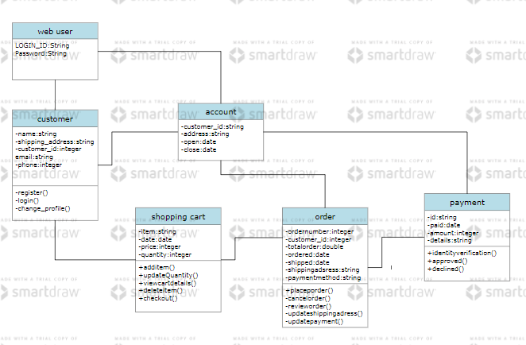

## 3.5 Object Diagram

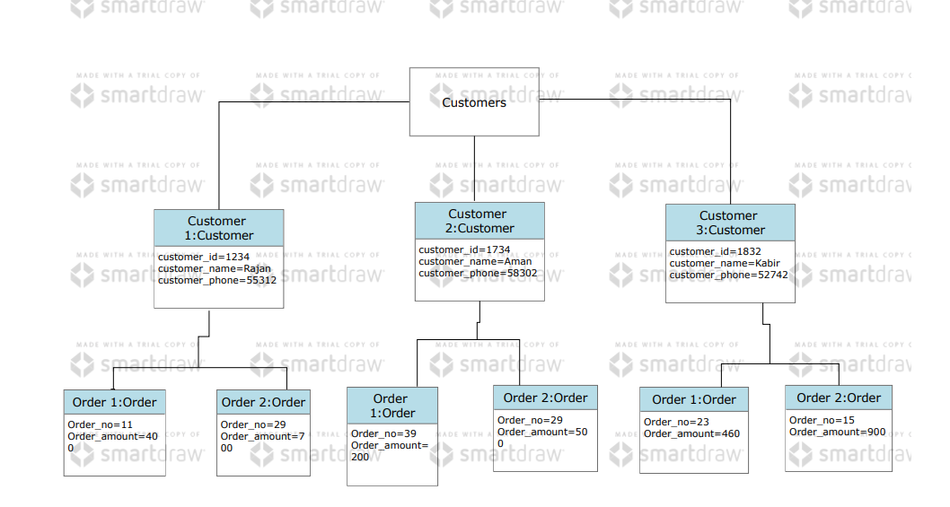

## 3.7 Package Diagram

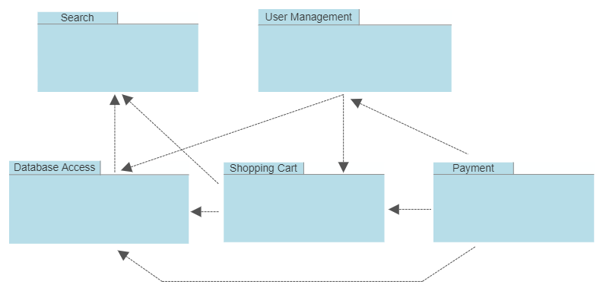

## 3.8 Deployment Diagram

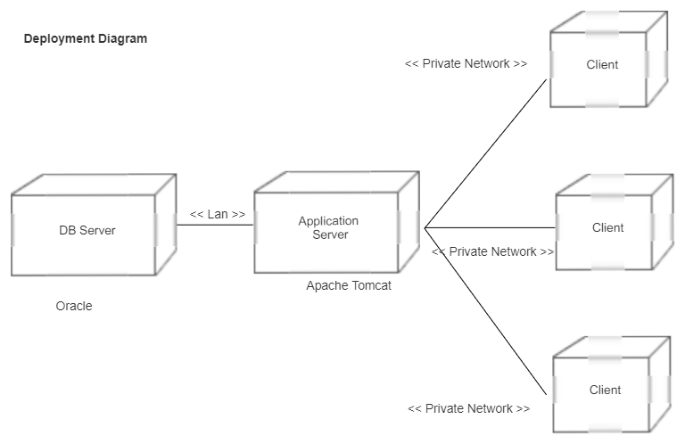

# 4. Analysis of consumer behaviour online

The report outlines about the most relevant behavioural characteristics of online consumers and examine the ways they find, compare and evaluate product information. Comparison of the newly collected survey data with the existing consumer behaviour theory resulted in detection of a number of issues related to a specific consumer group.

The purpose of this report is to translate these findings into a set of implementation activities on strategic and technological level. Execution of these recommendations will result in better conversion of visitors into customers and encourage customer loyalty and referrals.

The focus group of this study will be young adults aged between eighteen and thirty-four interested in buying a mobile phone or a related product.

Research by Shun & yunjie (2006) showed that there are product types, which are more likely to be sold online such as software, books, electronics and music. Reason for this is that when purchasing these types of products, one does not require personal inspection and most, if not all features, can be outlined in the product description and images. Most products in the mobile phone family belong to this category.

According to the recent research on consumer behaviour on the Internet users (Cotte, Chowdhury, Ratenshwar & Ricci, 2006), there are four distinct consumer groups with different intentions and motivations:

• Exploration

• Entertainment

• Shopping

• Information

Majority of young adults interviewed for purpose of this research tend to be active information seekers. A high level of technological confidence within this group tends to be an encouraging factor when it comes to product information research online. The following analysis presents both, focus group results and behavioural theory in a parallel fashion divided into two main research topics:

• Information Retrieval and Search Patterns

• Perception of Product Information Online

These two areas are mutually dependent and particularly important in a market where consumers have the power to choose the right product from a number of competing suppliers. Well-structured product information that cannot be found easily online is as much of a problem as is having easily accessible information that does not meet the consumer‘s expectations. The purpose of this report is to translate these findings into a set of implementation activities on strategic and technological level. Execution of these recommendations will result in better conversion of visitors into customers and encourage customer loyalty and referrals.

# 5. Results, Data analysis and Discussions

This chapter aims obtain the objective of the study by critically analysing the qualitative data through thoroughly examining the interviewee‘s responses and beliefs.

This has been achieved through evaluating the most relevant responses by the participants. The data has been analysed and discussed by comparing the comments made by the respondents with the literature review keeping in mind the research objective of the study. Thus, the rationale of this analysis is based on the personal answers provided by the respondents. An appropriately designed questionnaire was used to collect the primary data for the study. The data for 100 respondents was organized systematically in tables and graphs and then was subjected to analysis using appropriate statistical tools. The results of the analysis are presented in the following section in order to assess the customer perception towards online shopping on Flipkart.com in India. Here for analysing, we are considering two factors.

That is:

• Demographical factors

• Behavioural factors

## Demography Factor:

1. Gender of Respondents:

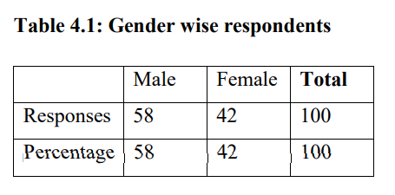

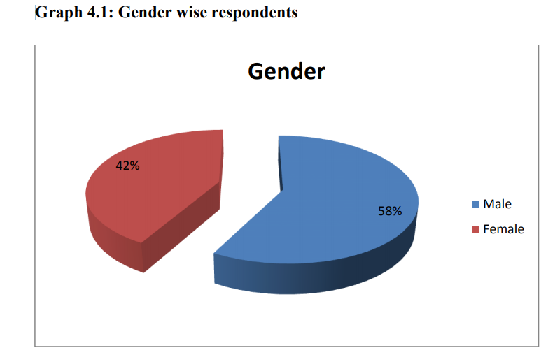

## 5.1 Analysis and Interpretation

According to demography profile, in this study 70 % male and 30% female respondents are part of my target population and they help me to fulfil my questionnaire from different area of Bangalore city. From these groups total respondents are 100. So, according to the survey result, the male respondents are more and can be told that they interested to shop online than female, even though both of them shop online.

2. Age Group:

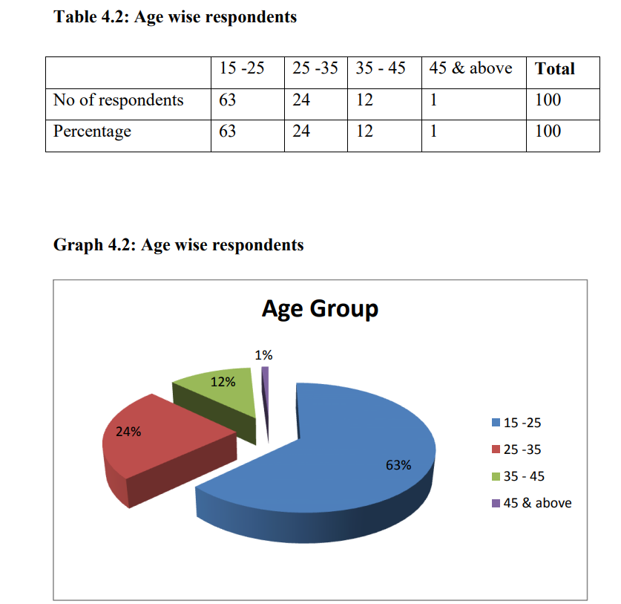

**Analysis and Interpretation:**

Below figure shows that 63% respondents are between 15-25 years old, 24% respondents are between 25-35 years old, 12% respondents between 35-45 years old, and 1% respondents are between 45&above. Overall result shows that between all of them the respondents who has age limit between 15 to 35 years (63%+24%= 87%) people are more familiar to shop online on my target population.

3. Occupation:

**Analysis and Interpretation:**

In this survey, 46% of the respondents are salaried and 39% are students. So they both together made majority of respondent‘s percentage (85%). 8% are business persons and 7% are House wife. Salaried persons and students will always look for new technologies and new services which make them more comfort.

4. Educational Qualification:

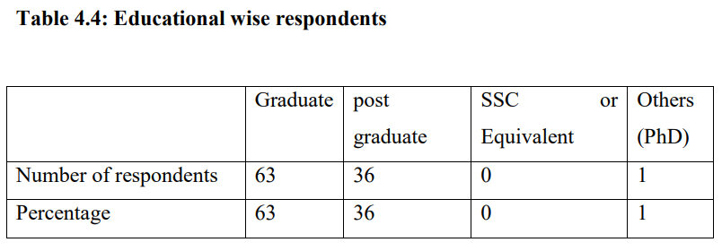

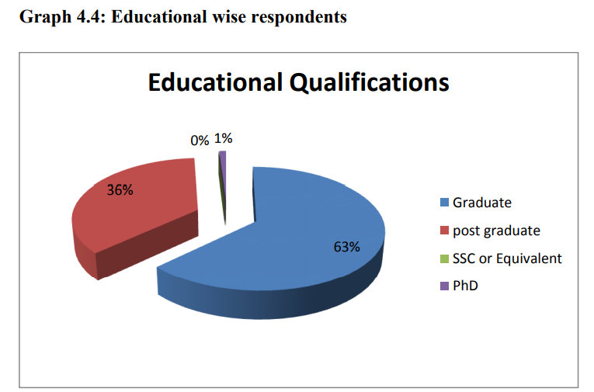

**Analysis and Interpretation:**

All of them in this survey are graduate and above qualified peoples only. Among these 63% are graduates, 36% are post graduates and one person is PhD.

5. Annual Income:

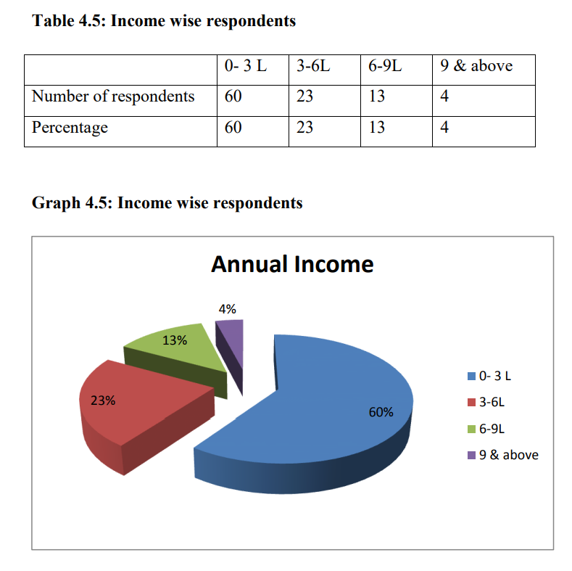

**Analysis and Interpretation:**

Since 39% of this survey is students most of them are of 0-3L income range, I.e. 60%. 23% of them are in 3-6L income range, 13% in 6-9L and 4% is 9 & above.

Behavioural factors:

This survey is conducted on those people who do online shopping and are aware of Flipkart. So everyone answered yes for those two questions.

6) Frequency of purchase from online:

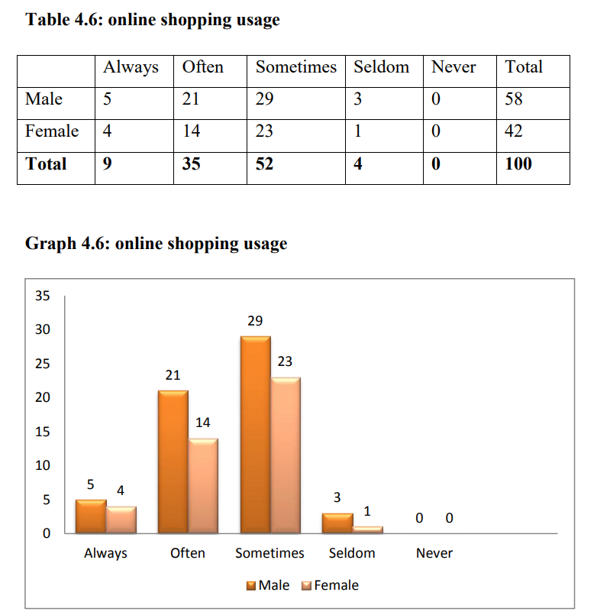

## Analysis and Interpretation:

More than half of them use online shopping sometimes, i.e. 52%. People who always and mostly shop through online shopping are also good in number, 9 and 35, together 44%. And who use online shopping rarely is very less in number 4%. Since only 44% are mostly using this, there is a wide space to fill and to make online shopping a great success. And there is not much gender difference in online shopping, which means both males and females enjoying online shopping and its benefits.

## Mode of awareness about Flipkart.com

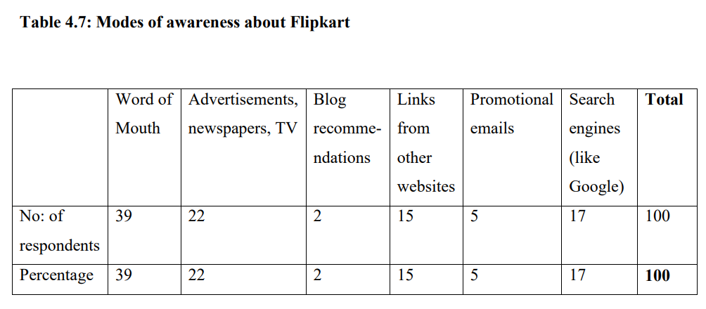

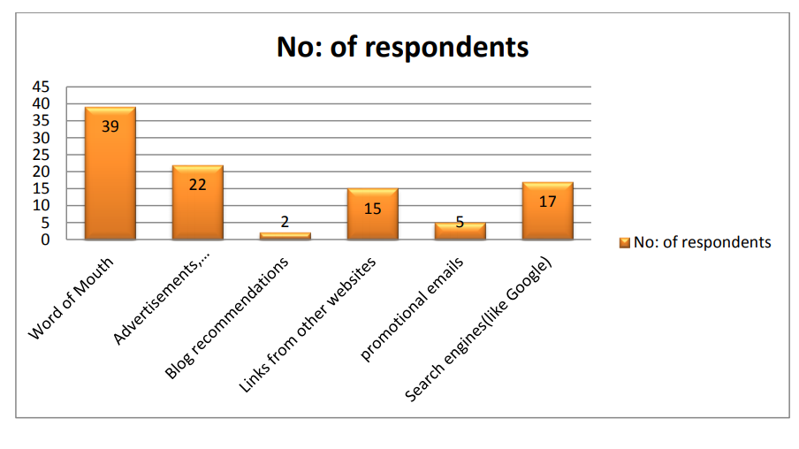

**Analysis and Interpretation:**

Most of them are aware about flip kart through word of mouth (39%) followed by television and online advertisements (22%). Customers got award through blog recommendations (2%) and promotional e-mails (5%) are very less in number. This means a good communication about Flip kart is going on through friends and families, which proves that word of mouth strategy by them is the most successful means of making people aware about their products. Success can only be gained through delighted customers who act as advocates for their products and there is a wide scope of other digital advertisement techniques like search engine marketing, email- marketing, providing links and blog recommendations in order to make more customers.

**TESTING**

Software Testing is an empirical investigation conducted to provide stakeholders with information about the quality of the product or service under test, with respect to the context in which it is intended to operate. Software Testing also provides an objective, independent view of the software to allow the business to appreciate and understand the risks at implementation of the software. Test techniques include, but are not limited to, the process of executing a program or application with the intent of finding software bugs. It can also be stated as the process of validating and verifying that a software program/application/product meets the business and technical requirements that guided its design and development, so that it works as expected and can be implemented with the same characteristics.

Software Testing, depending on the testing method employed, can be implemented at any time in the development process, however the most test effort is employed after the requirements have been defined and coding process has been completed.

* 1. **Unit Testing:**

The primary goal of unit testing is to take the smallest piece of testable software in the application, isolate it from the remainder of the code, and determine whether it behaves exactly as you expect. Each unit is tested separately before integrating them into modules to test the interfaces between modules. Unit tests are typically written and run by software developers to ensure that code meets it design and behaves as intended. Its implementation can vary from being very manual (pencil and paper) to being formalized as part of build automation.

* 1. **Integration Testing:**

Integration testing, also known as integration and testing (I&T), is a software development process which program units are combined and tested as groups in multiple ways. Integration testing can expose problems with the interfaces among program components before trouble occurs in real- world program execution. There are two major ways of carrying out an integration test, called the bottom-up method and the top-down method. Bottom-up integration testing begins with unit testing, followed by tests of progressively higher-level combinations of units called modules or builds. In top-down integration testing, the highest-level modules are tested first and progressively lower- levelmodules are tested after that. In a comprehensive software development environment, bottom-up testing is usually done first, followed by top-down testing.

* 1. **Validation testing:**

At the validation level, testing focuses on user visible actions and user recognizable output from the system. Validations testing is said to be successful when software functions in a manner that can be reasonably expected by the customer. Two types of validation testing

* Alpha testing is simulated or actual operational testing by potential users/customers or an independent test team at the developers' site. Alpha testing is often employed for off-the-shelf software as a form of internal acceptance testing, before the software goes to beta testing.
* Beta testing comes after alpha testing. Versions of the software, known as beta version, are released to a limited audience outside of the programming team. The software is released to groups of people so that further testing can ensure the product has few faults or bugs. Sometimes, beta versions are made available to the open public to increase the feedback field to a maximal number of future users

# 7. Conclusion

In general, today’s businesses must always strive to create the next best thing that consumers will want because consumers continue to desire their products, services etc. to continuously be better, faster, and cheaper. In this world of new technology, businesses need to accommodate to the new types of consumer needs and trends because it will prove to be vital to their business’ success and survival. E-commerce is continuously progressing and is becoming more and more important to businesses as technology continues to advance and is something that should be taken advantage of and implemented.

## 7.1 Limitations

* Security - The biggest drawback of e-commerce is the issue of security
* Lack of privacy - Many websites do not have high encryption for secure online transaction or to protect online identity
* Tax issue
* Product suitability
* Cultural obstacles
* High Labour cost
* Legal issues

## 7.2 Future Scope

Information suggests the future of internet lies in mobiles. Experts say that 582 million people in India will use the Internet by 2019 and 70% of them will admittance the Web on mobile. This will reason to switch to app only model. Flipkart, Snapdeal, Amazon comes from users in small cities village and towns

In terms of future of e-commerce in the 21st century, experts predict the promising and glorious figures. In the foreseeable future, e-commerce will be confirmed as the major tool of sale for the goods and services. Successful e-commerce will become the notion which will be inseparable from the web because e-shopping is becoming more and more popular and natural. Thus, prevailing to future trends, e-commerce will have huge potential growth in sales and promotion.

Each year, there is a continuous growth in e-commerce deals. The volumes of sales for online store are much higher than the brick and mortars. To the present day, the internet sales boom the foundation for magnificent e-commerce future. To attract more customers, owners will not only have to increase the number of services available to them but also have to pay more attention to such elements like design, good presentation, etc.

# 8. References

1. <https://en.wikipedia.org/wiki/Amazon_(company)>
2. <https://www.smarthint.co/en/futuro-do-ecommerce/>
3. <https://www.robabdul.com/business/feasibility-study-cost-benefit-analysis-for-your-new-ecommerce-web-site/>